Local Light

📘 Definition
# Source: AI Source: Provided by: [Data Path: Persons Table -> ID Column: 1, Name_En Column: Motasem Essam] -> From: [ChatGPT] on [5/2/2026]
Local Light is the actual color of an object under normal lighting, without strong effects from highlights, shadows, or reflections.
It is also called the “local color”—the color an object naturally has.

🎨 How local light appears
# Source: AI Source: Provided by: [Data Path: Persons Table -> ID Column: 1, Name_En Column: Motasem Essam] -> From: [ChatGPT] on [5/2/2026]
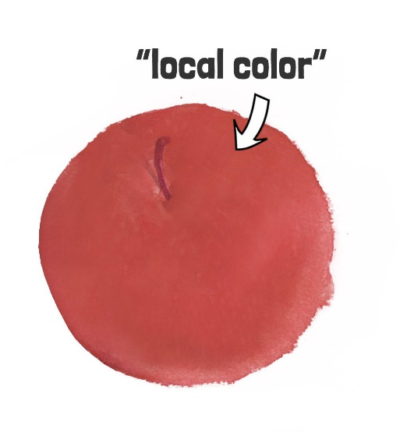
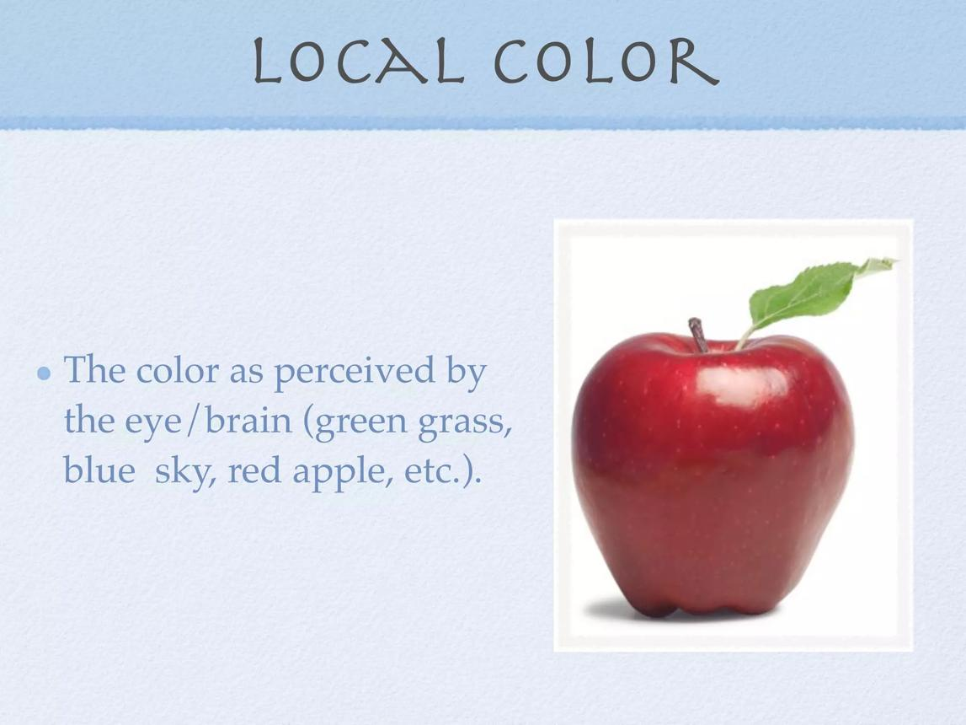
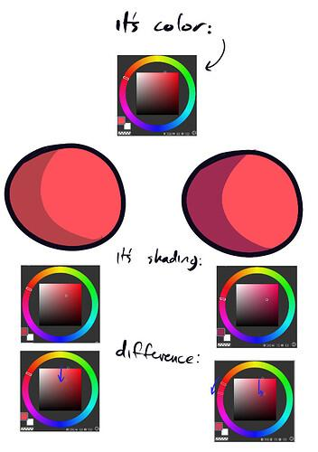
- It shows the true base color of the object
- Not affected much by:
  - Strong light (highlight)
  - Deep shadow
- Appears in the mid-lit areas

🧠 Simple example
# Source: AI Source: Provided by: [Data Path: Persons Table -> ID Column: 1, Name_En Column: Motasem Essam] -> From: [ChatGPT] on [5/2/2026]
Think of:
- 🍎 An apple → its local color is red
- 🍌 A banana → its local color is yellow
Even if lighting changes, the original color remains the same.

🎮 In computer graphics
# Source: AI Source: Provided by: [Data Path: Persons Table -> ID Column: 1, Name_En Column: Motasem Essam] -> From: [ChatGPT] on [5/2/2026]
Local light (color) is used to:
- Define the base color (texture) of objects
- Help shading models (like Lambert or Phong) calculate final color
- Keep objects recognizable under different lighting

⚙️ Key features
# Source: AI Source: Provided by: [Data Path: Persons Table -> ID Column: 1, Name_En Column: Motasem Essam] -> From: [ChatGPT] on [5/2/2026]
- 🎨 Represents true object color
- 🌤️ Seen in normal lighting areas
- 🚫 Not affected by extreme light or shadow
- 🧩 Important for realistic rendering

🚀 In short:
# Source: AI Source: Provided by: [Data Path: Persons Table -> ID Column: 1, Name_En Column: Motasem Essam] -> From: [ChatGPT] on [5/2/2026]
Local Light = the natural color of an object before lighting effects are applied.

